Task 1
Question1.cpp
#include"question 1.h"

//Question 1
//--------------------------------------------
//1. The Total Number of Relations
//2. Reflexive Relations
//3. Irreflexive Relations
//4. Symmetric Relations
//5. Anti - Symmetric Relations
//6. Asymmetric Relations

int main() {
int size1 = 0, size2 = 0, size3 = 0;
int* set1 = nullptr; int* set2 = nullptr; int* set3 = nullptr;
char count = 'NULL';
do
{
cout << "------------------Menu--------------------" << endl;
cout << "Press 1 to create a sets" << endl;
cout << "Press 2 the Total Number of Relations" << endl;
cout << "Press 3 to check a Reflexive relation" << endl;
cout << "Press 4 to check an Irreflexive relation" << endl;
cout << "Press 5 to check a Symmetric relation" << endl;
cout << "Press 6 to check an Anti-Symmetric relation" << endl;
cout << "Press 7 to check an Asymmetric relation" << endl;
cout << "Press 8 to display cartesian" << endl;
cout << "Press 0 to exit" << endl;
cout << "\nEnter a value: ";
cin >> count;
cout << endl;
switch (count)
{
case '1':
cout << "Enter size of set 1: ";
cin >> size1;
cout << "Enter size of set 2: ";
cin >> size2;
cout << endl;
set1 = new int[size1];
set2 = new int[size2];
cout << "Enter the values for set 1" << endl;
inputSet(set1, size1);
cout << "Enter the values for set 2" << endl;
inputSet(set2, size2);

break;
case '2':
if (size1 <= 0 || size2 <= 0)
{
cout << "Relations not created. Please create relation first." << endl;
break;
}

for (int i = 0; i < size1; i++)
{
for (int j = 0; j < size2; j++) {
size3++; size3++;
}
}

cout << "The total number of relations are: " << size3 / 2 << endl;
break;
case '3':
if (size1 <= 0 || size2 <= 0)
{
cout << "Relations not created. Please create relation first." << endl;
break;
}
reflexive(set1, set2, size1, size2);
break;
case '4':
if (size1 <= 0 || size2 <= 0)
{
cout << "Relations not created. Please create relation first." << endl;
break;
}
Irreflexive(set1, set2, size1, size2);
break;
case '5':
if (size1 <= 0 || size2 <= 0)
{
cout << "Relations not created. Please create relation first." << endl;
break;
}
symmetric(set1, set2, size1, size2);
break;
case '6':
if (size1 <= 0 || size2 <= 0)
{
cout << "Relations not created. Please create relation first." << endl;
break;
}
antiSymmetric(set1, set2, size1, size2);
break;
case '7':
if (size1 <= 0 || size2 <= 0)
{
cout << "Relations not created. Please create relation first." << endl;
break;
}
asymmetric(set1, set2, size1, size2);
break;
case '8':
if (size1 <= 0 || size2 <= 0)
{
cout << "Relations not created. Please create relation first." << endl;
break;
}
cartesianDisplay(set1, set2, size1, size2);
break;
case '0':
break;
default:
cout << "Are you Mad, you entered a wrong value!!" << endl;
break;
}
} while (count != '0');
delete[] set1;
delete[] set2;
delete[] set3;
return 0;
}
question 1.h
#pragma once
#include<iostream>
using namespace std;

/*============================================================================*/

//Question 1
//--------------------------------------------
//1. The Total Number of Relations
//2. Reflexive Relations
//3. Irreflexive Relations
//4. Symmetric Relations
//5. Anti - Symmetric Relations
//6. Asymmetric Relations

/*--------------------------------------------------- Inputing -------------------------------------------*/
//input elements into a set
template<typename T>
void inputSet(T* set, int size) {
if (size < 3) {
cout << "Size must be 3 or above." << endl;
return;
}
for (int i = 0; i < size; ++i) {
cout << "Enter element " << i + 1 << ": ";
cin >> set[i];
for (int j = 0; j < i; ++j) {
if (set[i] == set[j]) {
cout << "Duplicate value! Please enter a different value.\n";
--i;
break;
}
}
}
}

/*------------------------------------------------------- end ---------------------------------------------*/

/*---------------------------------------------------- Reflexive ------------------------------------------*/

//Reflexive
void reflexive(const int* set1, const int* set2, int size1, int size2)
{
int Reflexivecheck = 0;
for (int i = 0; i < size1; i++)
{
for (int j = 0; j < size2; j++)
{
if (set1[i] == set2[j])
{
Reflexivecheck = 1;
break;
}
else {
Reflexivecheck = 0;
}
}
}
if (Reflexivecheck)
{
cout << "Relation is Reflexive." << endl;
}
else
{
cout << "Relation is not Reflxive." << endl;
}
}

/*-------------------------------------------------------- end --------------------------------------------*/

/*---------------------------------------------------- Irreflexive ----------------------------------------*/

//Irreflexive
void Irreflexive(const int* set1, const int* set2, int size1, int size2) {
int irreflexivecheck = 1;
for (int i = 0; i < size1; i++)
{
for (int j = 0; j < size2; j++)
{
if (set1[i] == set2[j])
{
irreflexivecheck = 0;
break;
}
else {
irreflexivecheck = 0;
}
}
}
// checking reflexive relation
if (irreflexivecheck)
{
cout << "Relation is Irreflexive." << endl;
}
else
{
cout << "Relation is not irreflxive." << endl;
}
}

/*------------------------------------------------------ end ---------------------------------------------*/

/*---------------------------------------------------- Symmetric ------------------------------------------*/

//Symmetric
void symmetric(const int* set1, const int* set2, int size1, int size2)
{
int SymmetricCheck = 0;
for (int i = 0; i < size1; i++)
{
for (int j = 0; j < size2; j++)
{
if ((set1[i] == set2[j] && set1[i + 1] == set2[j + 1]) ||
(set1[i] == set2[j + 1] && set1[i + 1] == set2[j]))
{
SymmetricCheck = 1;
break;
}
else
{
SymmetricCheck = 0;
}
}
}
// checking symmetric relation
if (SymmetricCheck)
{
cout << "Relation is symmetric." << endl;
}
else
{
cout << "Relation is not symmetric." << endl;
}
}

/*---------------------------------------------------- end ------------------------------------------------*/

/*----------------------------------------------- Anti-Symmetric ------------------------------------------*/

//Anti-symmetric
void antiSymmetric(const int* set1, const int* set2, int size1, int size2)
{
int AntiSymmetricCheck = 1;
for (int i = 0; i < size1; i++)
{
for (int j = 0; j < size2; j++)
{
if ((set1[i] == set2[j] && set1[i + 1] == set2[j + 1]) ||
(set1[i] == set2[j + 1] && set1[i + 1] == set2[j]))
{
AntiSymmetricCheck = 0;
break;
}
}
}
// checking antisymmetric relation
if (AntiSymmetricCheck)
{
cout << "Relation is anti-symmetric." << endl;
}
else
{
cout << "Relation is not anti-symmetric." << endl;
}
}

/*---------------------------------------------------- end ------------------------------------------*/

/*---------------------------------------------------- Asymmetric ----------------------------------------*/

// Asymmetric
void asymmetric(const int* set1, const int* set2, int size1, int size2)
{
int asymmetricCheck = 1;
for (int i = 0; i < size1; i++)
{
for (int j = 0; j < size2; j++)
{
if (set1[i] == set2[j])
{
asymmetricCheck = 0;
break;
}
}
if (!asymmetricCheck)
{
break;
}
}
// Checking asymmetric relation
if (asymmetricCheck)
{
cout << "Relation is asymmetric." << endl;
}
else
{
cout << "Relation is not asymmetric." << endl;
}
}

/*---------------------------------------------------- end ------------------------------------------*/

/*---------------------------------------------------- Display ------------------------------------------*/

//Cartesian product Display
void cartesianDisplay(const int* set1, const int* set2, int size1, int size2) {
cout << "{";
for (int i = 0; i < size1; i++)
{
for (int j = 0; j < size2; j++)
{
cout << "(" << set1[i] << "," << set2[j] << ") ,";
}
}
cout << "}" << endl;
}
Output
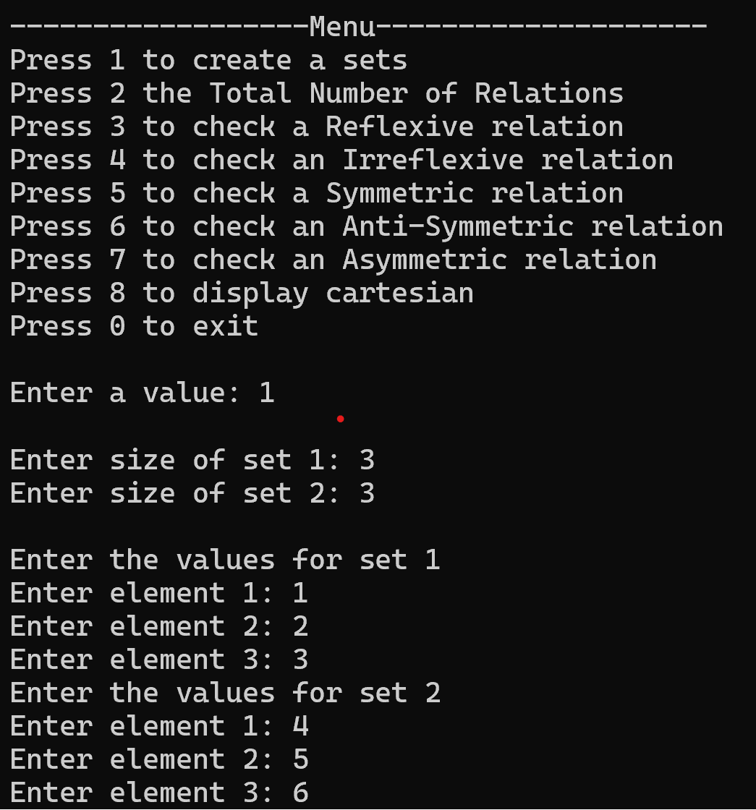
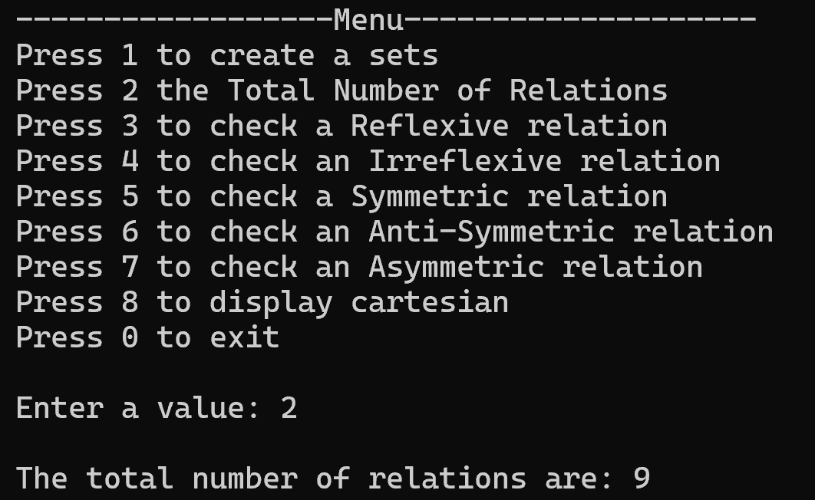
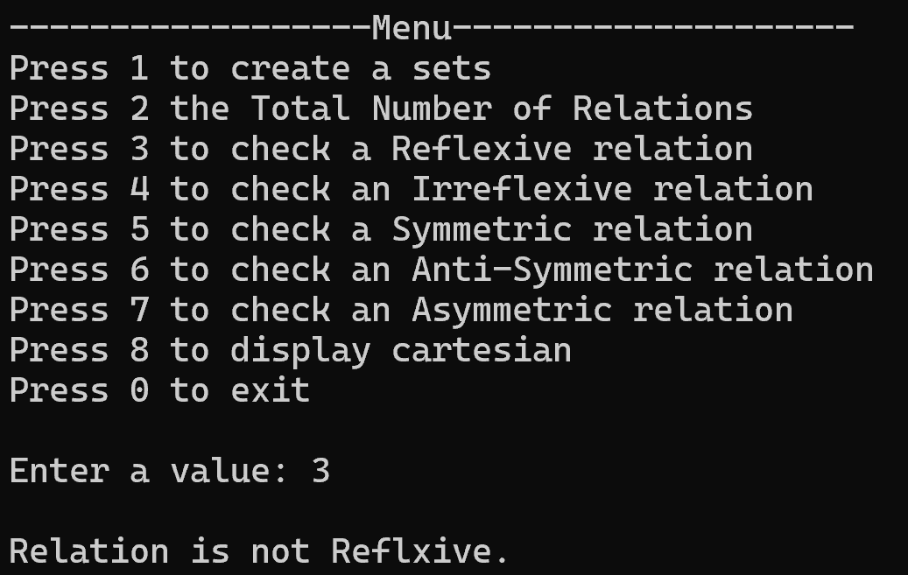
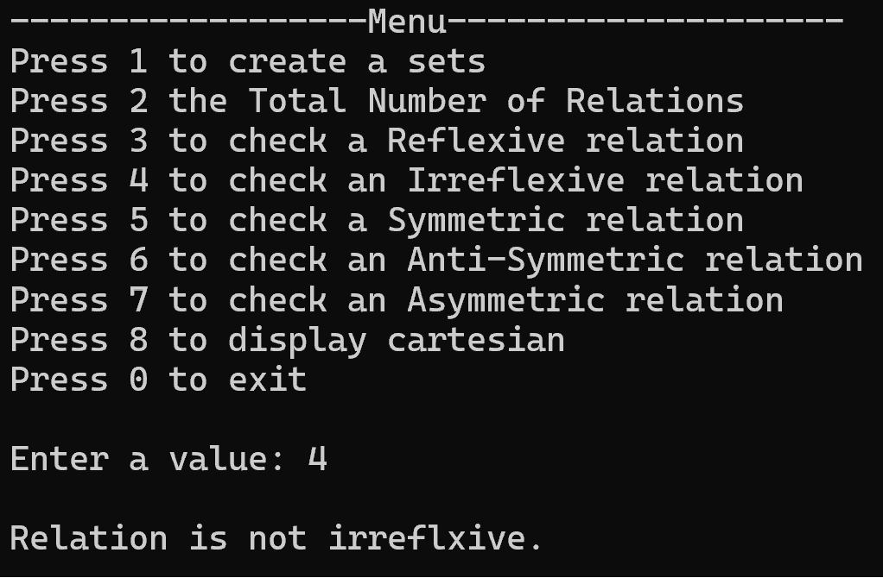
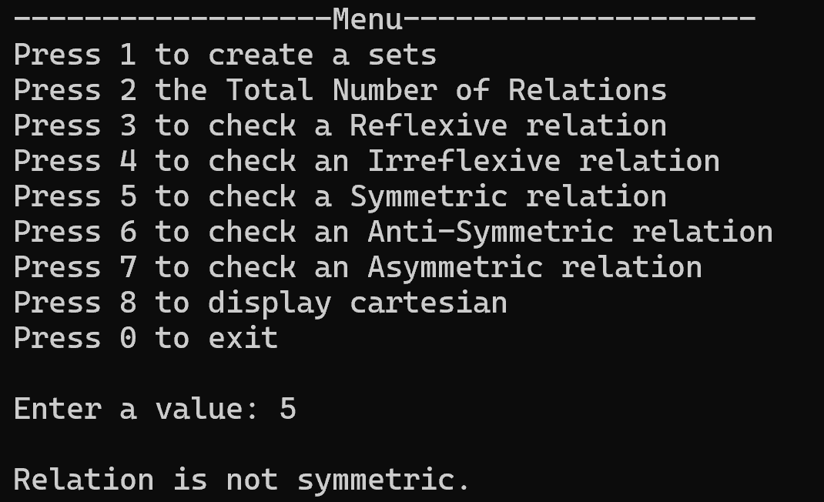
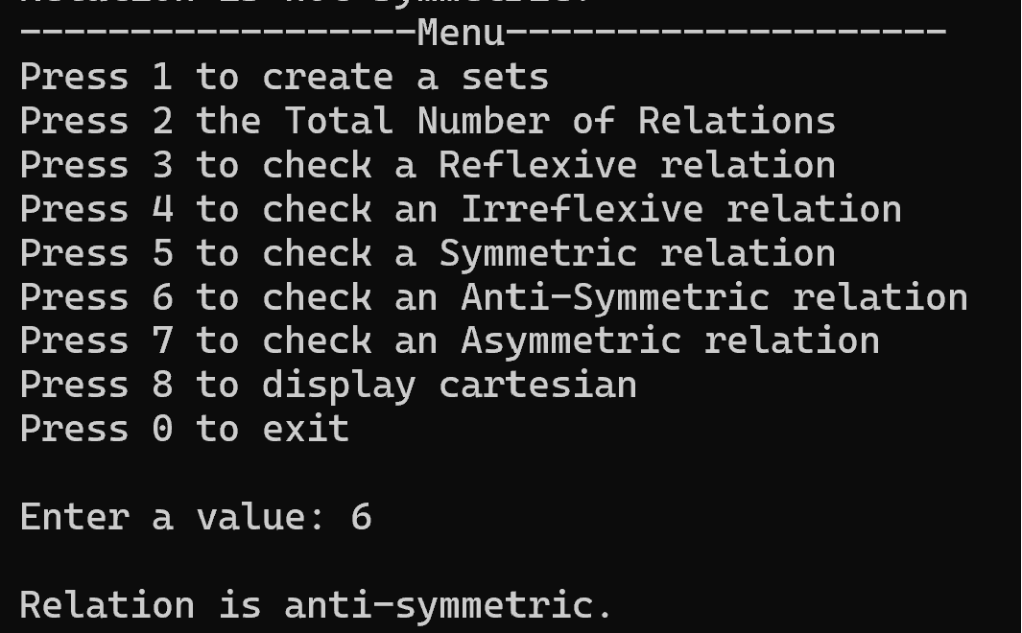
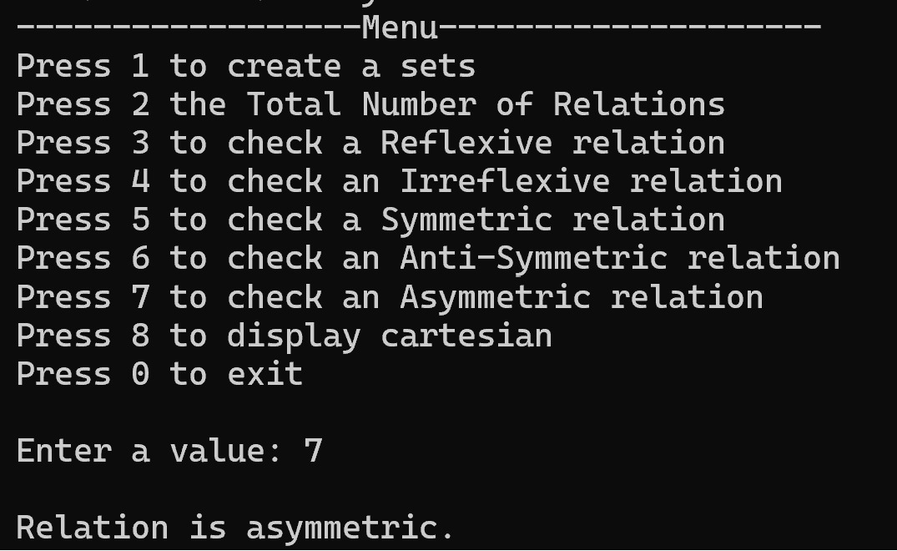
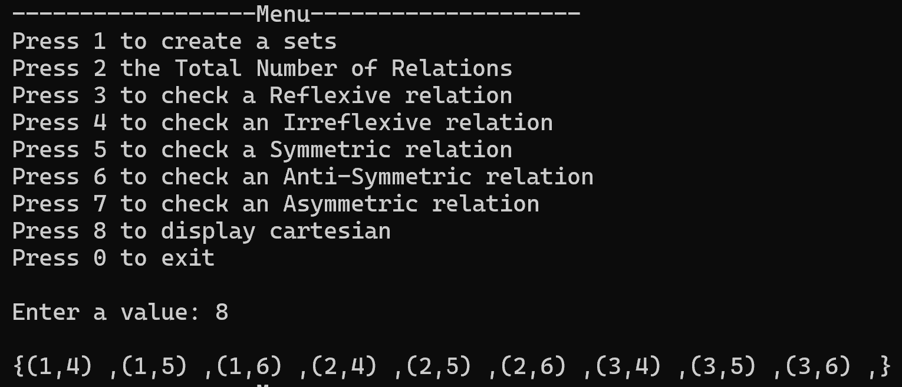
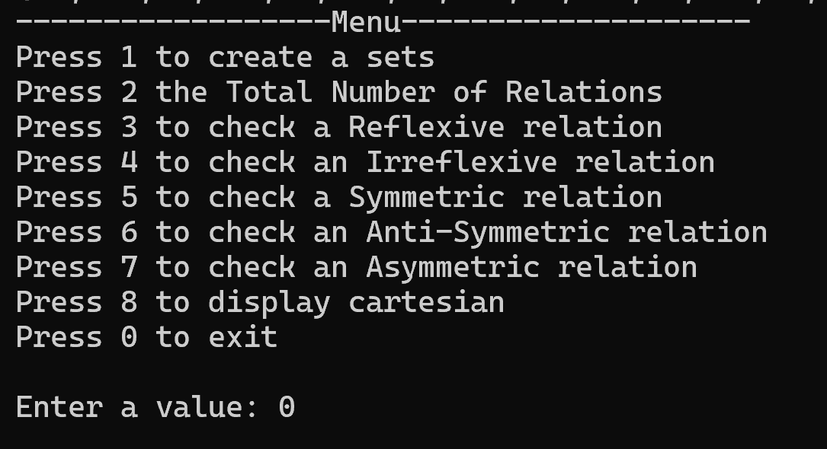
Task 2
Question2.cpp
#include"question 2.h"

// Question 2
//--------------------------------------------
//1. Set Creation and Display
//2. Union and Intersection
//3. Subset and Superset
//4. Set Difference
//5. Power Set Generation
//6. Cardinality Calculation
//7. Set Equality
//8. Set Complement

// Prototype for saving data to a file
void saveData(const char* set1, int size1, const char* set2, int size2, const string& filename);

// Prototype for loading data from a file
void loadData(char*& set1, int& size1, char*& set2, int& size2, const string& filename);

int main() {
char* set1 = nullptr;
char* set2 = nullptr;
char* set3 = nullptr;
char* universalSet = nullptr;
int size1 = 0, size2 = 0, size3 = 0, universalSize = 0;
int count = 0;
string filename = "data.txt";

do
{
cout << "------------------Menu--------------------" << endl;
cout << "Press 1 to create a set and Display sets" << endl;
cout << "Press 2 to create and display Union of set or Intersection of set" << endl;
cout << "Press 3 to create and display Subset of set or Superset of set" << endl;
cout << "Press 4 to create and display Set Difference of set" << endl;
cout << "Press 5 to create and display Power Set Generation of set" << endl;
cout << "Press 6 to create and display Cardinality Calculation of set" << endl;
cout << "Press 7 to create and display Set Equality of set" << endl;
cout << "Press 8 to create and display Set Complement of set" << endl;
cout << "Press 9 to get data from file" << endl;
cout << "Press 0 to upload data in File" << endl;
cout << "Press -1 to exit" << endl;
cout << "\nEnter a value: ";
cin >> count;
cout << endl;

switch (count)
{
case 1:
cout << "Enter size of set 1: ";
cin >> size1;
cout << "Enter size of set 2: ";
cin >> size2;
cout << endl;
set1 = new char[size1];
set2 = new char[size2];
cout << "Enter the values for set 1" << endl;
inputSet(set1, size1);
cout << "Enter the values for set 2" << endl;
inputSet(set2, size2);
setDisplay(set1, set2, size1, size2);
break;
case 2:
if (size1 <= 0 || size2 <= 0)
{
cout << "Relations not created. Please create relation first." << endl;
break;
}
setUnion(set1, size1, set2, size2);
setIntersection(set1, size1, set2, size2);
fileUnion(set1, size1, set2, size2, "union.txt");
fileIntersection(set1, size1, set2, size2, "intersection.txt");
break;
case 3:
if (size1 <= 0 || size2 <= 0)
{
cout << "Relations not created. Please create relation first." << endl;
break;
}
if (subset(set2, size2, set1, size1))
cout << "Set 2 is a subset of Set 1." << endl;
else
cout << "Set 2 is not a subset of Set 1." << endl;

if (superset(set1, size1, set2, size2))
cout << "Set 1 is a superset of Set 2." << endl;
else
cout << "Set 1 is not a superset of Set 2." << endl;
break;
case 4:
if (size1 <= 0 || size2 <= 0)
{
cout << "Relations not created. Please create relation first." << endl;
break;
}
setDifference(set1, size1, set2, size2);
break;
case 5:
set3 = new char[size3];
cout << "Enter size of set 3: ";
cin >> size3;
cout << "Enter the values of set to find power set" << endl;
inputSet(set3, size3);
powerSet(set3, size3);
break;
case 6:
if (size1 <= 0 || size2 <= 0)
{
cout << "Relations not created. Please create relation first." << endl;
break;
}
cout << "Cardinality of the set 1: ";
cardinality(set1, size1);
cout << "Cardinality of the set 2: ";
cardinality(set2, size2);
break;
case 7:
if (size1 <= 0 || size2 <= 0)
{
cout << "Relations not created. Please create relation first." << endl;
break;
}
if (setEquality(set1, size1, set2, size2))
cout << "The sets are equal.\n";
else
cout << "The sets are not equal.\n";
break;
case 8:
if (size1 <= 0 || size2 <= 0)
{
cout << "Relations not created. Please create relation first." << endl;
break;
}
universalSet = new char[universalSize];
cout << "Enter size of universal set: ";
cin >> universalSize;
cout << "Enter the values of set to find Compliment of sets" << endl;
inputSet(universalSet, universalSize);
cout << endl;
cout << "Complement of set 1 is: ";
setComplement(universalSet, set1, universalSize, size1);
cout << endl;
cout << "Complement of set 2 is: ";
setComplement(universalSet, set2, universalSize, size2);
break;
case 9:
loadData(set1, size1, set2, size2, filename);
break;
case 0:
saveData(set1, size1, set2, size2, filename);
break;
case -1:
break;
default:
cout << "Are you Mad, you entered a wrong value!!" << endl;
break;
}
} while (count != -1);
delete[] set1;
delete[] set2;
delete[] set3;
delete[] universalSet;
return 0;
}

//Definition of saveData function
void saveData(const char* set1, int size1, const char* set2, int size2, const string& filename) {
ofstream outputFile(filename);
if (!outputFile.is_open()) {
cout << "Error opening file: " << filename << endl;
return;
}

//Save the size of sets and then the elements
outputFile << size1 << endl;
for (int i = 0; i < size1; ++i)
outputFile << set1[i] << " ";
outputFile << endl;

outputFile << size2 << endl;
for (int i = 0; i < size2; ++i)
outputFile << set2[i] << " ";
outputFile.close();

cout << "Data saved successfully to " << filename << endl;
}

//Definition of loadData function
void loadData(char*& set1, int& size1, char*& set2, int& size2, const string& filename) {
ifstream inputFile(filename);
if (!inputFile.is_open()) {
cout << "Error opening file: " << filename << endl;
return;
}

//Read and display the size of sets
inputFile >> size1;
cout << "Size of set 1: " << size1 << endl;
set1 = new char[size1];
cout << "Elements of set 1: ";
for (int i = 0; i < size1; ++i) {
inputFile >> set1[i];
cout << set1[i] << " ";
}
cout << endl;

inputFile >> size2;
cout << "Size of set 2: " << size2 << endl;
set2 = new char[size2];
cout << "Elements of set 2: ";
for (int i = 0; i < size2; ++i) {
inputFile >> set2[i];
cout << set2[i] << " ";
}
cout << endl;

inputFile.close();

cout << "Data taken successfully from " << filename << endl;
}
question 2.h
#pragma once
#include<iostream>
#include <fstream>
using namespace std;

/*============================================================================*/

// Question 2
//--------------------------------------------
//1. Set Creation and Display
//2. Union and Intersection
//3. Subset and Superset
//4. Set Difference
//5. Power Set Generation
//6. Cardinality Calculation
//7. Set Equality
//8. Set Complement

/*------------------------------------------ Inputing & displaying -------------------------------------*/

//input elements into a set(array)
template<typename T>
void inputSet(T* set, int size) {
if (size < 0) {
cout << "Size must be 3 or above." << endl;
return;
}
for (int i = 0; i < size; ++i) {
cout << "Enter element " << i + 1 << ": ";
cin >> set[i];
for (int j = 0; j < i; ++j) {
if (set[i] == set[j]) {
cout << "Duplicate value! Please enter a different value.\n";
--i;
break;
}
}
}
}

// storing sets in txt file
template<typename T>
void inputfile(const T* set1, const T* set2, int size1, int size2, const string& filename) {
ofstream outputFile(filename);
if (!outputFile.is_open()) {
cout << "Error opening file: " << filename << endl;
return;
}
outputFile << "Set 1 is: {";
for (int i = 0; i < size1; i++)
{
outputFile << set1[i];
if (i != size1 - 1)
outputFile << ",";
}
outputFile << "}\n";
outputFile << "Set 2 is: {";
for (int i = 0; i < size2; i++)
{
outputFile << set2[i];
if (i != size2 - 1)
outputFile << ",";
}
outputFile << "}\n";
outputFile.close();
}

//Set Display without txt file
template<typename T>
void setDisplay(const T* set1, const T* set2, int size1, int size2) {
cout << "Set 1 is: ";
cout << "{";
for (int i = 0; i < size1; i++)
{
cout << set1[i] << ",";
}
cout << "}";
cout << endl;
cout << "Set 2 is: ";
cout << "{";
for (int i = 0; i < size2; i++)
{
cout << set2[i] << ",";
}
cout << "}" << endl;
}

/*----------------------------------------------- End --------------------------------------------------*/

/*------------------------------------------- Union / Intersection -------------------------------------*/

//union of two sets(array)
template<typename T>
void setUnion(const T* set1, int size1, const T* set2, int size2) {
T* set3 = new T[size1 + size2];
for (int i = 0; i < size1; ++i)
set3[i] = set1[i];
int size3 = size1;
for (int i = 0; i < size2; ++i) {
bool found = false;
for (int j = 0; j < size1; ++j) {
if (set2[i] == set1[j]) {
found = true;
break;
}
}
if (!found)
set3[size3++] = set2[i];
}
cout << "Union: { ";
for (int i = 0; i < size3; ++i)
cout << set3[i] << " ";
cout << "}\n";

delete[] set3;
} //---------------end---------------------
//intersection of two sets(array)
template<typename T>
void setIntersection(const T* set1, int size1, const T* set2, int size2) {
T* set3 = new T[size1];
int size3 = 0;
for (int i = 0; i < size1; ++i) {
for (int j = 0; j < size2; ++j) {
if (set1[i] == set2[j]) {
bool check = false;
for (int k = 0; k < size3; ++k) {
if (set1[i] == set3[k]) {
check = true;
break;
}
}
if (!check)
set3[size3++] = set1[i];
break;
}
}
}
cout << "Intersection: { ";
for (int i = 0; i < size3; ++i)
cout << set3[i] << " ";
cout << "}\n";
delete[] set3;
}//------------end-----------------
//union of two sets in txt file
template<typename T>
void fileUnion(const T* set1, int size1, const T* set2, int size2, const string& filename) {
ofstream outputFile(filename);
if (!outputFile.is_open()) {
cout << "Error opening file: " << filename << endl;
return;
}
T* set3 = new T[size1 + size2];
for (int i = 0; i < size1; ++i)
set3[i] = set1[i];
int size3 = size1;
for (int i = 0; i < size2; ++i) {
bool found = false;
for (int j = 0; j < size1; ++j) {
if (set2[i] == set1[j]) {
found = true;
break;
}
}
if (!found)
set3[size3++] = set2[i];
}
outputFile << "Union: { ";
for (int i = 0; i < size3; ++i)
outputFile << set3[i] << " ";
outputFile << "}\n";
delete[] set3;
outputFile.close();
}//-------------end-----------------
// interection of two sets in txt file
template<typename T>
void fileIntersection(const T* set1, int size1, const T* set2, int size2, const string& filename) {
ofstream outputFile(filename);
if (!outputFile.is_open()) {
cout << "Error opening file: " << filename << endl;
return;
}
T* set3 = new T[size1];
int size3 = 0;
for (int i = 0; i < size1; ++i) {
for (int j = 0; j < size2; ++j) {
if (set1[i] == set2[j]) {
bool check = false;
for (int k = 0; k < size3; ++k) {
if (set1[i] == set3[k]) {
check = true;
break;
}
}
if (!check)
set3[size3++] = set1[i];
break;
}
}
}
outputFile << "Intersection: { ";
for (int i = 0; i < size3; ++i)
outputFile << set3[i] << " ";
outputFile << "}\n";
delete[] set3;
outputFile.close();
}//--------------------end------------------------

/*----------------------------------------------- End --------------------------------------------------*/

/*------------------------------------------- subset / superset ----------------------------------------*/

//Set Subset
template<typename T>
bool subset(const T* set1, int size1, const T* set2, int size2) {
for (int i = 0; i < size1; ++i) {
bool found = false;
for (int j = 0; j < size2; ++j) {
if (set1[i] == set2[j]) {
found = true;
break;
}
}
if (!found)
return false;
}
return true;
}//------------------end--------------------

//Superset of sets(array)
template<typename T>
bool superset(const T* set1, int size1, const T* set2, int size2) {
for (int i = 0; i < size2; ++i) {
bool found = false;
for (int j = 0; j < size1; ++j) {
if (set2[i] == set1[j]) {
found = true;
break;
}
}
if (!found)
return false;
}
return true;
}//---------------------end--------------------------

/*----------------------------------------------- End --------------------------------------------------*/

/*------------------------------------------- set difference -------------------------------------------*/

//Set Difference
template<typename T>
void setDifference(const T* set1, int size1, const T* set2, int size2) {
cout << "Set Difference (Set1 - Set2): { ";
bool found;
for (int i = 0; i < size1; ++i) {
found = false;
for (int j = 0; j < size2; ++j) {
if (set1[i] == set2[j]) {
found = true;
break;
}
}
if (!found)
cout << set1[i] << " ";
}
cout << "}\n";
}

/*----------------------------------------------- End --------------------------------------------------*/

/*--------------------------------------------- power set ----------------------------------------------*/

//Power Set Generation
template<typename T>
void powerSet(const T* set, int size) {
cout << "Power Set:\n";
for (int i = 0; i < (1 << size); ++i) {
cout << "{ ";
for (int j = 0; j < size; ++j) {
if (i & (1 << j))
cout << set[j] << " ";
}
cout << "}\n";
}
}

/*----------------------------------------------- End --------------------------------------------------*/

/*------------------------------------------- Cardinality ----------------------------------------------*/

//Cardinality Calculation
template<typename T>
void cardinality(const T* set, int size) {
cout << size;
}

/*----------------------------------------------- End --------------------------------------------------*/

/*--------------------------------------------- equality -----------------------------------------------*/

//Set Equality
template<typename T>
bool setEquality(const T* set1, int size1, const T* set2, int size2) {
if (size1 != size2)
return false;
char* temp1 = new char[size1];
char* temp2 = new char[size2];
for (int i = 0; i < size1; i++)
{
for (int j = 0; j < size2; j++) {
temp1[i] = set1[i];
temp2[j] = set2[j];
}
}
for (int i = 0; i < size1 - 1; ++i) {
for (int j = 0; j < size1 - i - 1; ++j) {
if (temp1[j] > temp1[j + 1]) {
T temp = temp1[j];
temp1[j] = temp1[j + 1];
temp1[j + 1] = temp;
}
if (temp2[j] > temp2[j + 1]) {
T temp = temp2[j];
temp2[j] = temp2[j + 1];
temp2[j + 1] = temp;
}
}
}
for (int i = 0; i < size1; ++i) {
if (set1[i] != set2[i])
return false;
}
return true;
}

/*----------------------------------------------- End --------------------------------------------------*/

/*--------------------------------------------- compliment ---------------------------------------------*/

//Set Complement
template<typename T>
void setComplement(T* univeralSet, T* set2, int universalSize, int size2) {
cout << "{ ";
bool found;
for (int i = 0; i < universalSize; ++i) {
found = false;
for (int j = 0; j < size2; ++j) {
if (univeralSet[i] == set2[j]) {
found = true;
break;
}
}
if (!found)
cout << univeralSet[i] << " ";
}
cout << "}\n";
}

/*----------------------------------------------- End --------------------------------------------------*/

Output
